Exercise #5

In this exercise you will practice:

Opening a file Printing a document
Previewing a document Closing a file

- Open the file newspaper article.

- Preview the document.

(Remember: Click on File➔ Print).

This is what you should see:

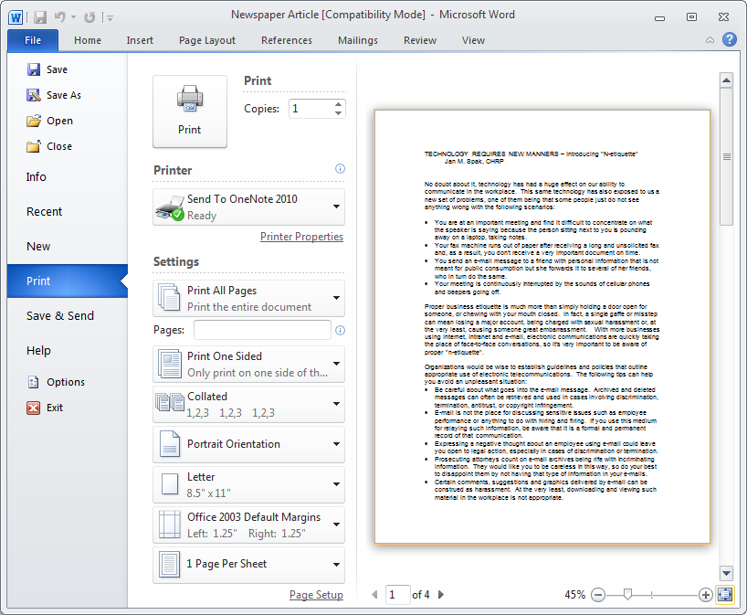

3. If you are satisfied with its appearance, print the document.

Remember: To avoid wasting printing materials – paper and ink or toner, preview your document prior to printing.

